Setup of the TVMA802
- Connecting the software ((SurfaceMount) C:\Users\Anton\Downloads\English-20160321-V2.12-20170226T095937Z-001\English-20160321-V2.12) to the machine
- After the software has been downloaded the network adapter settings need to be changed to connect to the device
- Go to Control Panel and select Nework and sharing center
- Change adapter settings
- Right click Ethernet Network and select properties
- Select Internet Protocol Version 4 and go to properties
- Set IP address as 192.168.0.7
Subnet Mask as 255.255.255.0
Gateway as 192.168.0.1
Then click OK

- Camera Setup:
When the software is connected to the machine go to system config and select camera. Set the Serial Numbers to the values below and the camera should connect
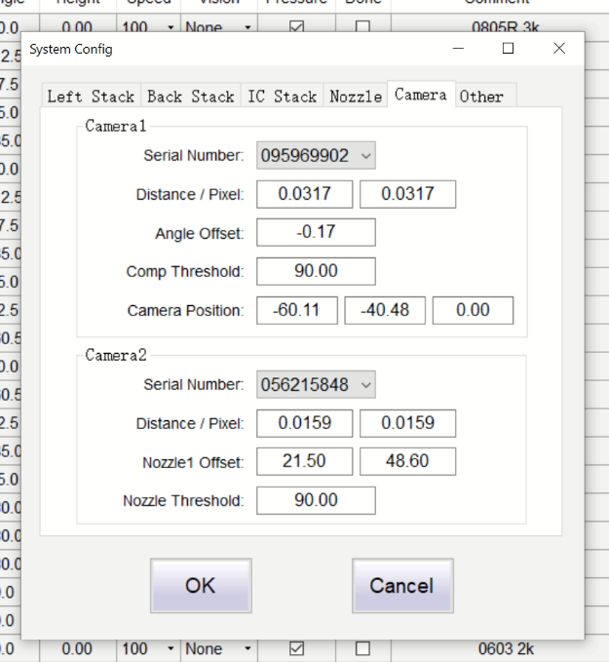

Click on the camera window a few times to see the image

- Start placing:
- From the design program set the origin of the pcb
- And export the file to a csv file
In KiCad go to the pcb file and select file, Fabrication Outputs and select Footprint Position File
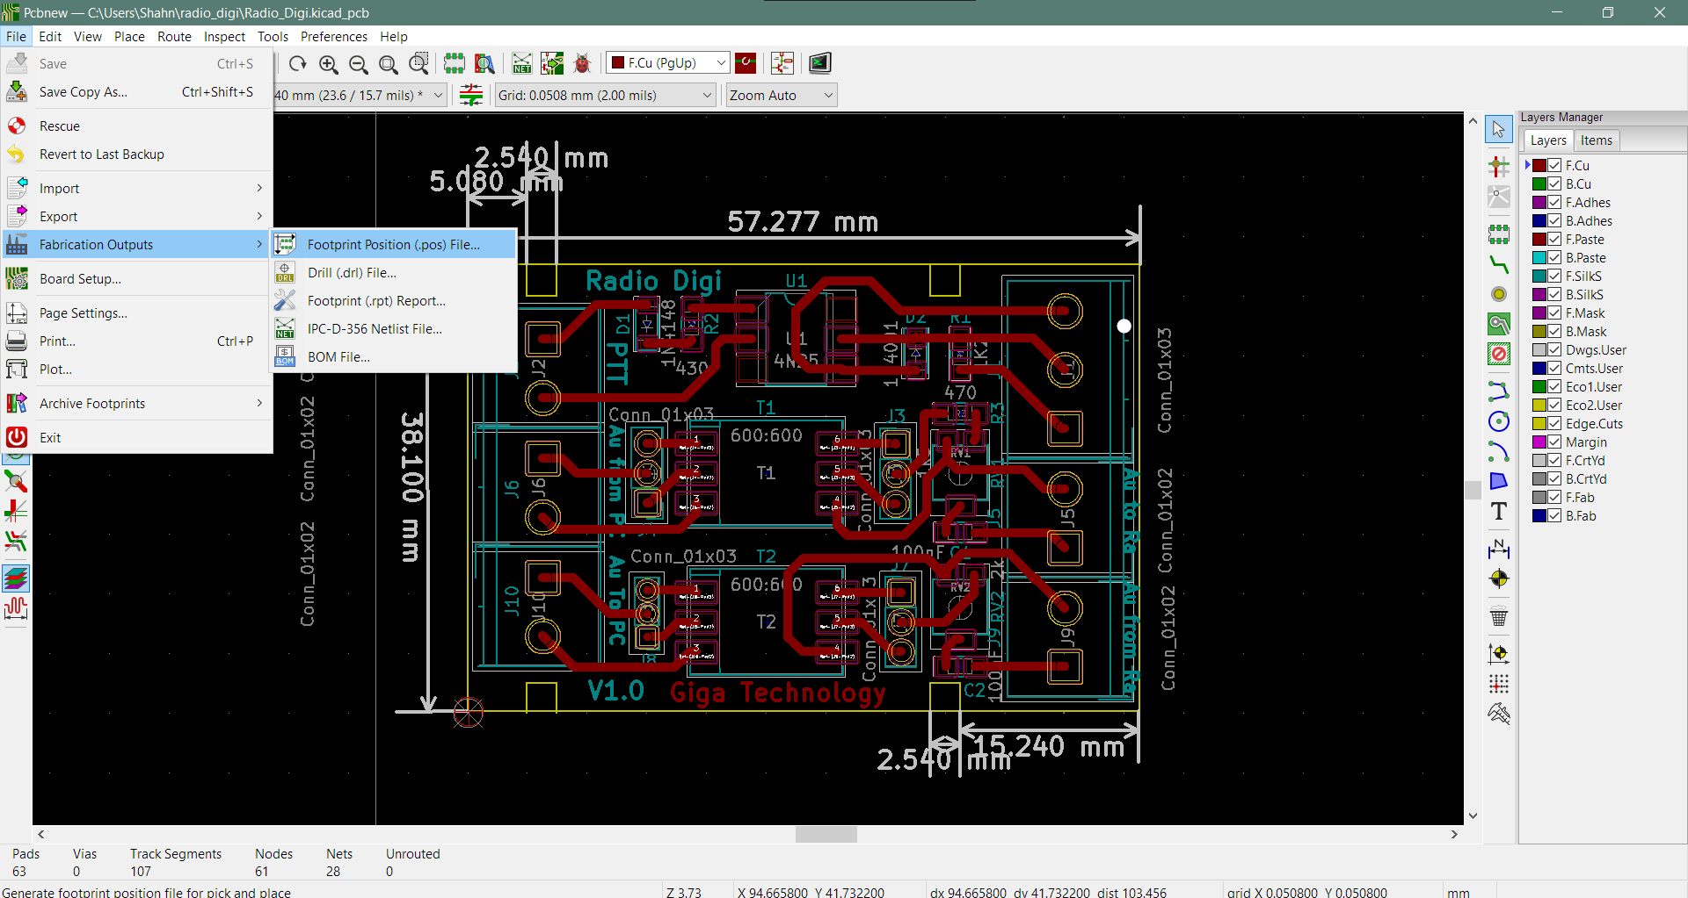
From here the file must be set in the following way
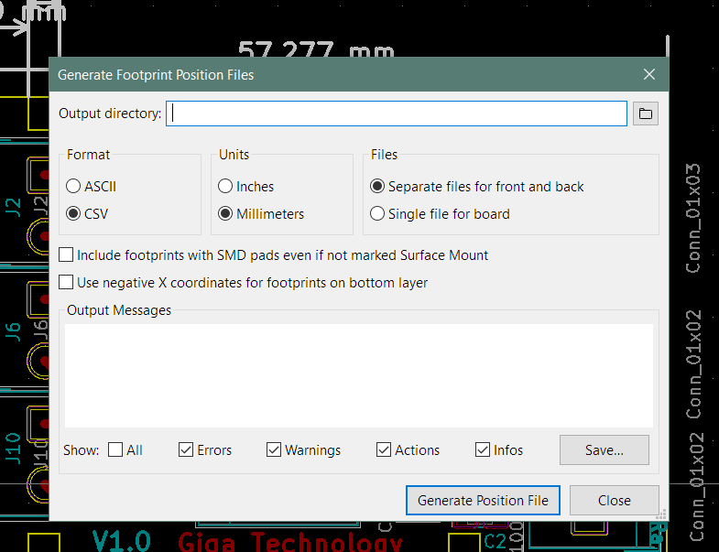
Then you can generate the position file
Once the position file has been generated for the PCB the next step is to change the file so that it is in line with the TVM802A format, for this a python script is used.

Getting the correct CSV file for the TVM802A
- Download the python file from the following link https://github.com/nica-f/tvm802-mdgen
- Use the tvm802-mdgen.py file
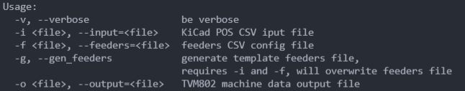
- To run this script the following command must be entered to run the script

These tell you which names are required where.
The full path to the file location is necessary to generate the appropriate files
The commands below were entered in VSCode
The first command is:
python tvm802-mdgen.py -i ./(path to KiCad csv position file) -g -f ./(path to where file must be saved and the file name)
This will generate the file required to set the feeders for the various components. These must be entered manually

After the feeder file has been updated it can then be used to generate the csv file for the TVM802A. To generate this the following command is run:
python tvm802-mdgen.py -i ./(path to KiCad csv position file) -f ./(path to feeder file) -o ./(path to output file location and the file name)
Below is an image of the commands being run in VisualStudio Code and how it was saved and named for the VHF_UHF_Duplexer
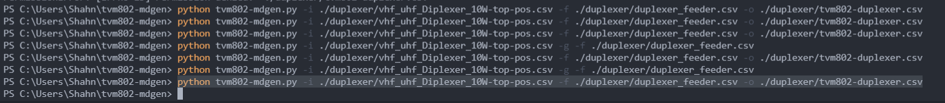

Once this file has been created it can now be uploaded to the TVM802 SurfaceMount program.

Uploading and running in SurfaceMount:
Below is an image of the software
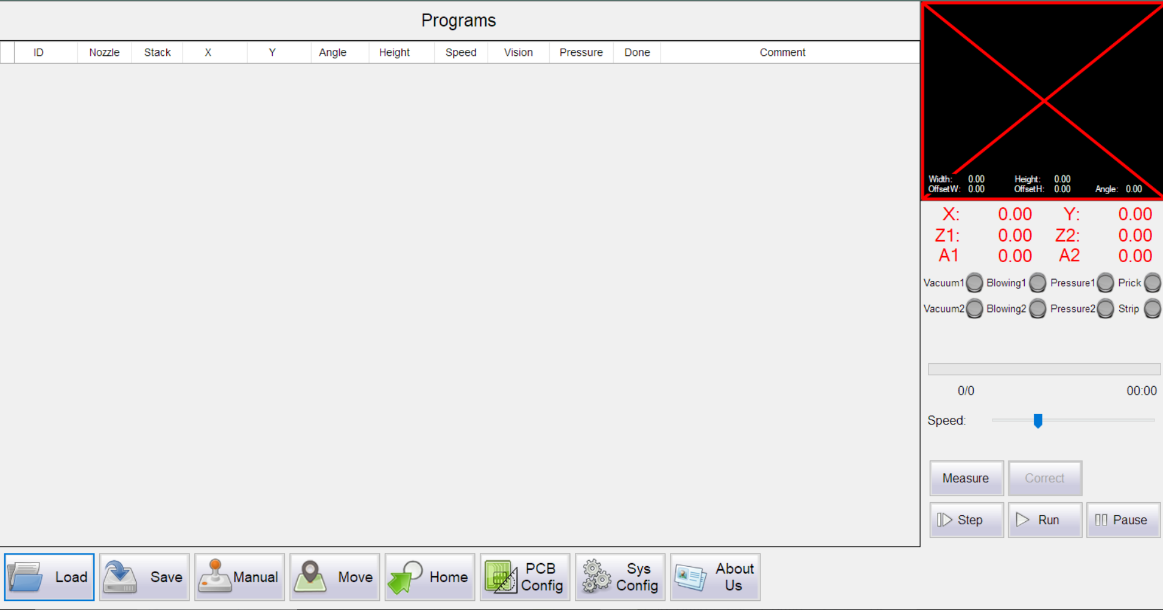
In this window click on Load and select the file that was just created using the python script
(It should be noted that it is necessary to open the file in excel and saved so that it is in fact in the correct format. If this is not done then the following error wilL appear)
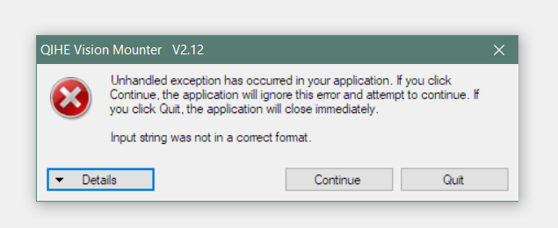

In some cases when the file is opened in Excel and saved, Excel may have added unnecessary spaces and symbols. In these cases, a new error will appear on the screen as seen below.
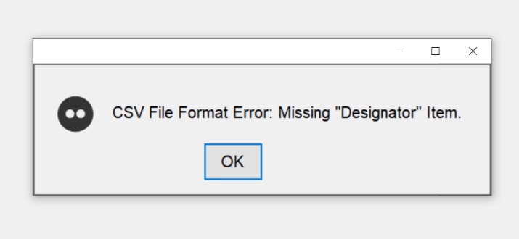
In these cases, a program such as Notepad++ is used to see the unnecessary commands and remove them. The image below is an example of how the file needs to be formatted to be read by the machine.

Once these values have been found return to the pick and place software and go to PCB config.

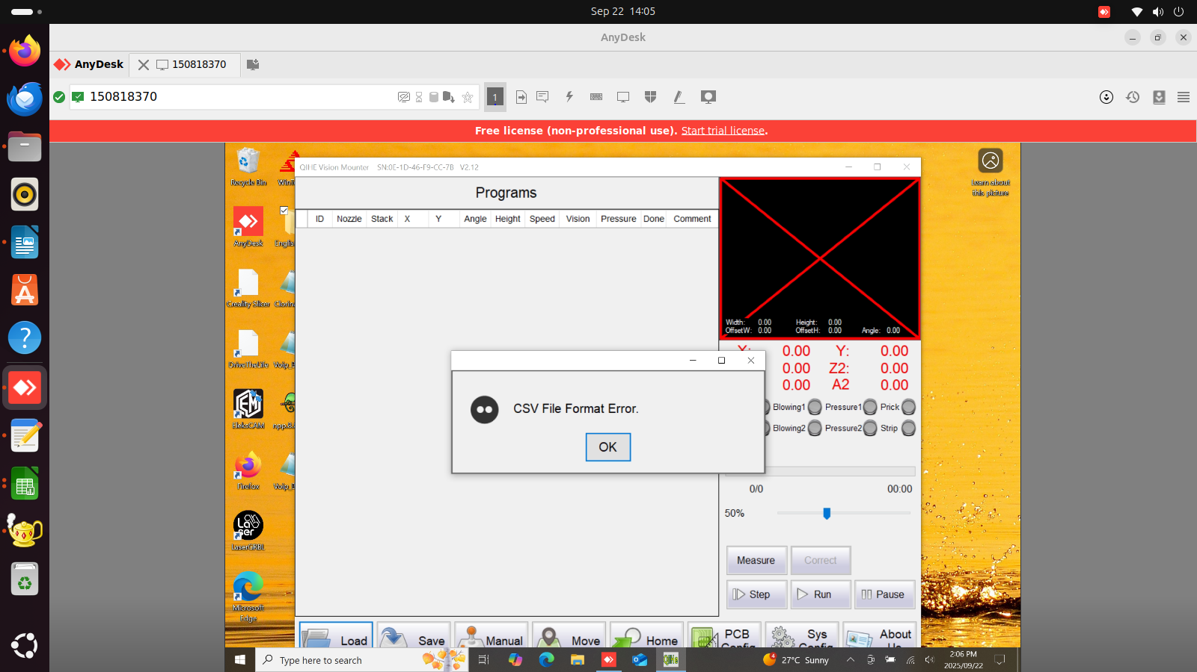
(Note: In case of CSV File Format Error make sure that the StackNum values are populated)

In case of boolean error make sure to remove all the data apart from the component data from the .csv placement file.
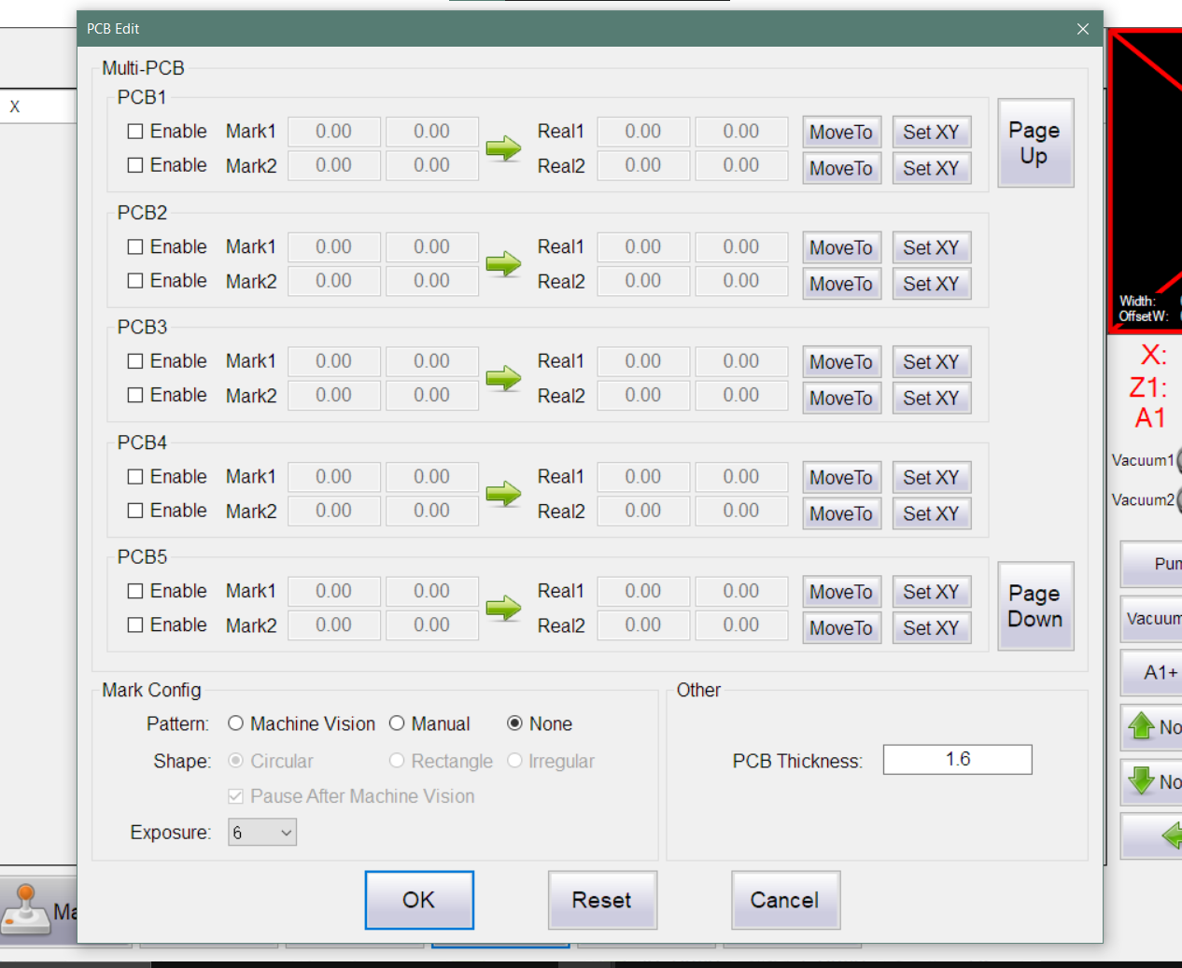
The above window should appear. Enable the number of marks that were made for the PCB. And enter the values that were read from KiCad into the Mark columns. Once this has been done it is time to find the real values of these marks.
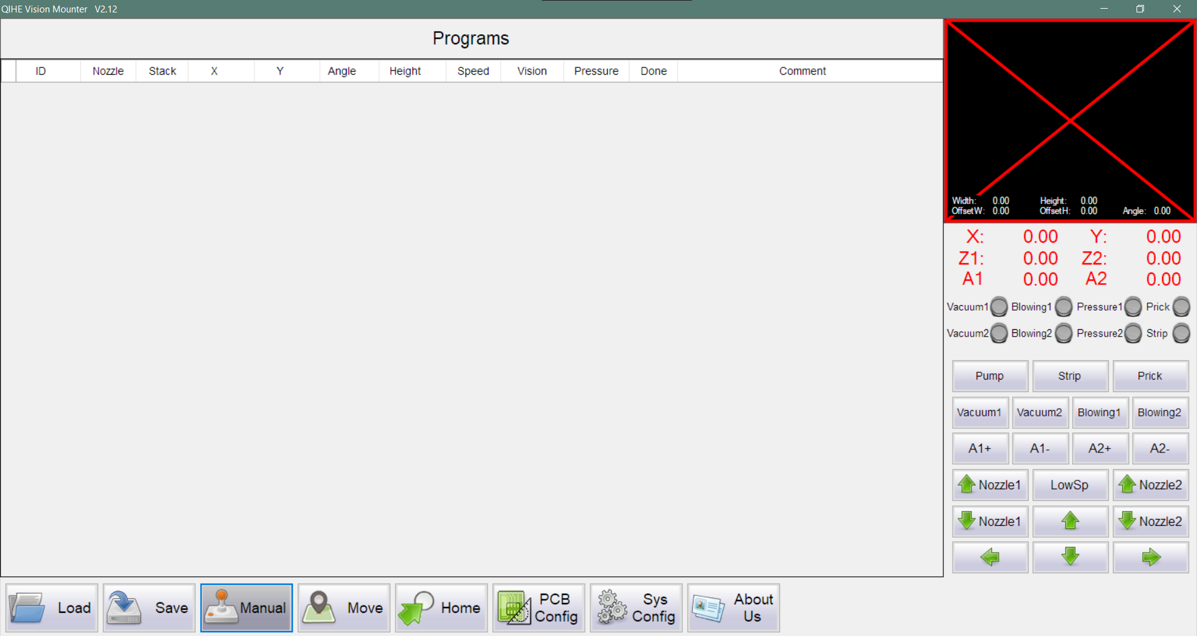
Go to the Manual option, this will allow you to move the camera over the marks on the real pcb. Move the camera over Mark 1, return to the PCB config window and click on Set XY for Real 1. Continue this process until all the marks have a value from KiCad as well as the real position.

Once this has been done run the Home command, load the reels with the components and the machine is then ready to pick and place

